Ecosystems: Cycles of Matter Name: _________________________________
(Read Ch. 3.3; pgs. 79-86)

1. How is the movement of MATTER through the biosphere different from the flow of energy? ___________________________
___Matter is recycled within and between ecosystems. Energy flows through the ecosystem (one-way)___________
2. DRAW the visual analogy (figure 3-8) showing the difference between the two. (Include labels)

3. What are biogeochemical cycles? _How elements are cycled (passed) from the biosphere, geosphere, hydrosphere and
atmosphere__
4. What powers these cycles? ___the flow of energy through the biosphere_______

5. Review the 4 types of processes that make up biogeochemical cycles. Using the table below:
- Where does each process take place
- Give multiple examples of each

Biological processes  Activities/ processes performed by living organisms (biosphere)  Also takes place in Hydro, Geo, and Atmosphere  Photosynthesis, Cellular respiration, eating, eliminating waste | Geological Processes  Deals with formation/ breaking down of sediment. Mainly in geosphere  Volcanic eruptions, formation of rock - magma
Physical and Chemical Processes  Occurs primarily in Hydrosphere, Atmosphere and geosphere  Cloud formation, Storms, Lightning, Flow of water - erosion | Human Activities  Humans using resources on a daily → yearly basis. Effects all 4 spheres  Mining, use of fossil fuels, clearing land/ Reforestation, use of fertilizers

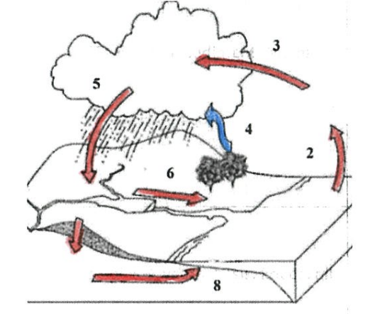
Read textbook pg. 81 & Analyze figure 3-10 to answer the following questions.

6. What 2 processes (#’s 2 & 4) cause water to enter the atmosphere?
___Evaporation___ & ___Transpiration_____

7. Read the caption info on figure 3-10. COLOR the arrows either red or blue in the
diagram to the right.

8. What process causes water to move from the atmosphere to the
ground? Precipitation

9. Processes 6 & 8 have arrows that lead to the ocean. What processes are they?
6 = ___Surface runoff____ 8= ____Groundwater____

10. NAME the only process that is considered biological. __Transpiration___ WHY is it considered biological?
This process is biological because it occurs through plants, a living organism.

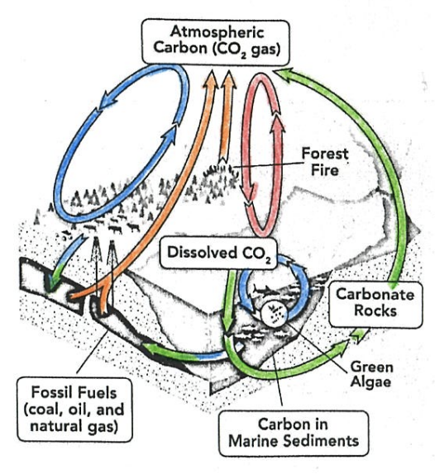
Read textbook pgs. 82-83 & use figure 3-12 to complete the following.
11. Use colored pencils to color the arrows in the diagram on the right according
to the processes listed in the key in fig. 3-12

12. Now use figure 3-12 to summarize the 4 biogeochemical processes of the
CARBON cycle. Make sure to read the ‘boxes’ in the figure

Biological processes  Plants remove CO₂ from the atmosphere building carbohydrates which feed heterotrophs. Plants and animals respire, releasing CO₂ to the atmosphere | Geological Processes  Pressure and heat turn organic matter to fossil fuels over millions of years  Marine sediments turn into rocks  Volcanoes release CO₂ to atmosphere
Physical and Chemical Processes  CO₂ dissolves in oceans and returns to the atmosphere  CO₂ also dissolves into rainwater | Human Activities  Burning of fossil fuels and forests releases CO₂

13. Read the caption, in figure 3-12, How does carbon move from the biological process (living system) to geological process
(fossil fuels)? Living matter is DECOMPOSED and then pressure and heat turn organic matter to fossil fuels over millions of
years

14. Read the caption, in figure 3-12. How does carbon enter into the biological processes?
Producers take it in through the process of photosynthesis

16. What is the main difference between the 2 biological processes shown in figure 3-12?
The CO₂ is dissolved in water as well as being released into the atmosphere.

Nitrogen Cycle & Nutrient Limitation → Read textbook pgs. 87 - 88
17. Now use figure 3-16 to summarize the 3 biogeochemical processes of the Nitrogen cycle. Make sure to read the ‘boxes’ in
the figure
Biological processes  -Bacteria fix N₂ Gas  -Nitrogen in taken up by producers, reused by consumers and released by excretion and decomposing matter  -Bacteria release N₂ gas through denitrification | Physical and Chemical Processes  -Some N₂ gas is fixed by lightning | Human Activities  -N₂ gas is turned into fertilizer and applied to crops.  - Excess may wash into water supplies as runoff

18. What is the difference between nitrogen fixation and denitrification?
(use the following format; Nitrogen fixation ____…while denitrification ________..)
Nitrogen fixation turns nitrogen into usable forms (nitrites and nitrates) while denitrification turns nitrates into unusable
N₂ gas.

19. What is primary productivity?
The rate at which primary productivity (photosynthesis) create new organic material

20. What happens to a food web if a nutrient is limited?
If a nutrient is in short supply, it limits the organic material that primary producers can create which then limits the amount
of material and energy for the rest of organisms, decreasing populations

